Heaven’s Light Is Our Guide


Rajshahi University of Engineerig &
Technology

Project Report

EEE-2288

Electro-mechanical Systems and Drives Sessional.

Project Title : Building a hand made DC motor along with a wireless control system.

Name | ID
Fahim Faisal | 2008001
Fahad Bin Islam | 2008002
Nishat Pervez Meghoboti | 2008003
Ariful Islam Riad | 2008004
Homayra Mobesshira Hemu | 2008005
Nurul Sajjad | 2008006
Submitted To : Sharafat Islam Abhi Submitted By :
Assisstant Professor
Dept. of MTE
RUET

Submitted To : Md. Hafiz Ahmed
Assisstant Professor
Dept. of MTE
RUET

Project Title
Building a hand made DC motor along with a wireless control system.

Objectives

- To make a control system of the motor.
- To wirelessly control the motor using internet
- To measure the speed of the motor
- To control the speed of the motor using PWM signal from the microcontroller
- To display the speed of the motor and set input

Introduction
The project represents an exploration into the in the realm of electrical machines. DC motors hold a significant place among electrical devices due to their wide range of applications in industries, robotics, and various electronic devices.

The primary objective of this project is to provide with hands-on experience in designing, constructing, and testing a basic DC motor. Through this endeavor, participants will gain insights into the core concepts governing electromagnetic induction, rotational motion, and electrical circuitry.

This report will delve into the theoretical underpinnings of DC motors, elucidating the principles of electromagnetic fields, armature winding, and commutation. It will document the step-by-step process of constructing the DC motor, outlining the selection of materials, the construction of the rotor and stator, and the wiring of the electrical components.

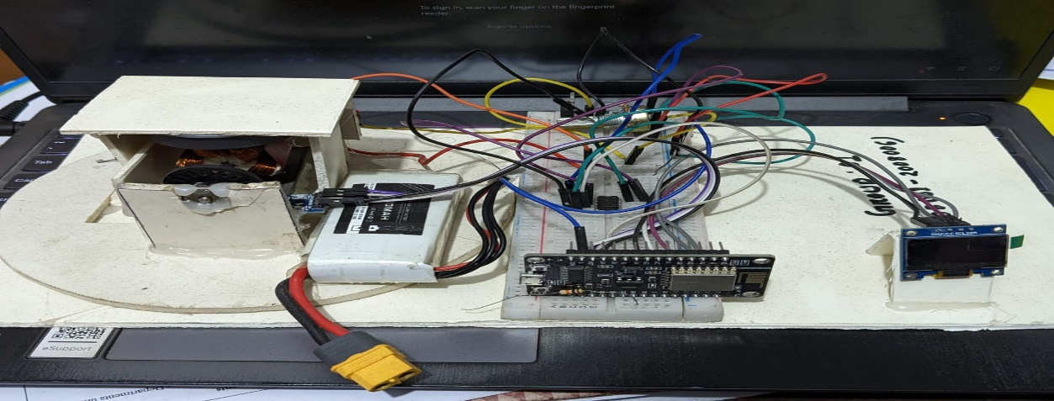
Furthermore, the report will detail the experimental procedures undertaken to evaluate the motor's performance, including measurements of speed, torque, and efficiency. The results obtained will be analyzed to assess the practical implications of the theoretical concepts discussed.
Figure 1:Hand made DC motor with control system

Components Used
- DC motor Shaft
- Insulated copper winding wires
- Copper Sheet
- Thick Copper wires (as brush)
- Esp-8266 node-MCU (microcontroller)
- Power MOSFET(IRF-Z44N)
- Op-amp (LM358)
- Optical Encoder
- Potentiometer
- Jumper wires
- Breadboard
- Battery
- PVC board
Components | Price
Steel Motor Shaft | 40 tk
Insulated copper winding wires | 20 tk
Permanent Magnets | 80 tk
Copper Sheet | 20 tk
Thick Copper wires (as brush) | 10 tk
Esp-8266 node-MCU (microcontroller) | 380 tk
Power MOSFET (IRF-Z44N) | 60 tk
Op-amp (LM358) | 50 tk
Optical Encoder | 130 tk
Potentiometer | 20 tk
OLED Display | 220 tk
Jumper wires | 30 tk
Breadboard | 60 tk
Battery | 1200 tk
PVC board | 20 tk

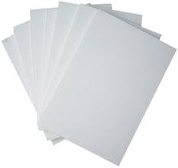
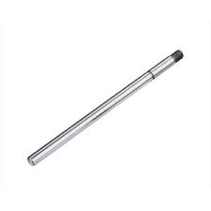
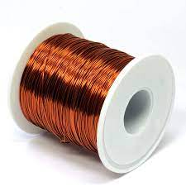
Components With Figure

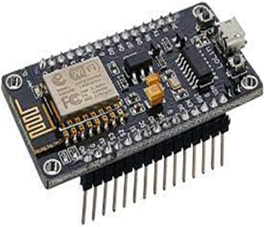
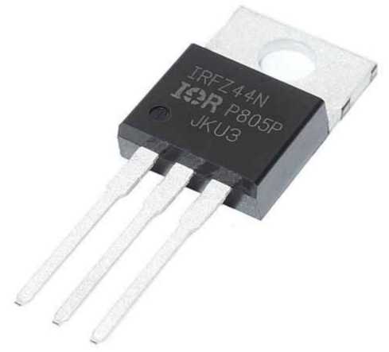
Figure 2: Insulated Copper wire Figure 3: steel shaft Figure 4: PVC sheet
Figure 6: ESP-8266 microcontroller
Figure 7: IRFZ44N MOSFET
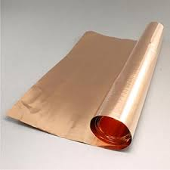
Figure 5: Copper Sheet

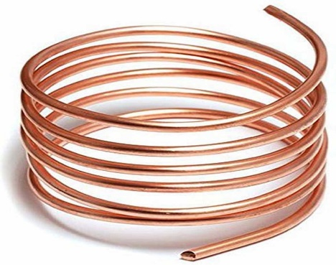
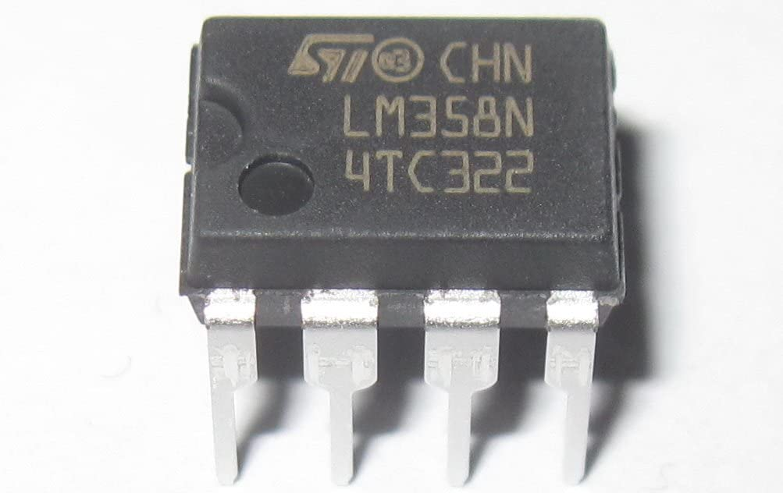
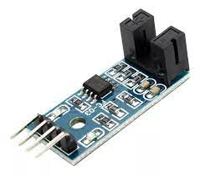
Figure 10: Copper wire
Figure 8: Optical Encoder

Figure 9: LM358N Op-Amp

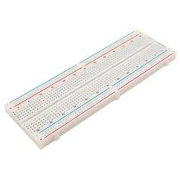
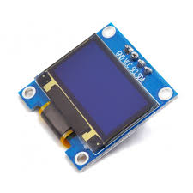
Figure 13: Bread board
Figure 11: OLED Display
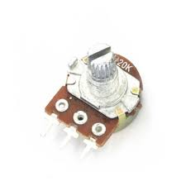
Figure 12: Potentiometer

Construction
The motor is built using a rigid shaft which holds five armatures and commutator at the bottom to form the rotor as a whole. Each of the armature holds a coil of 80 turns and each of the five commutator segments are connected sequentially with each of the armature. For the main magnetic field from stator , two permanent magnets were used. Two pieces of copper wire were used as brushes that are directly touched with the commutators. These brushes are connected with the power source. The whole motor arrangement is placed on a PVC sheet. The rotor shaft also holds a slotted disk which is paired with the optical encoder.
The control unit is placed on the same PVC sheet. The heart of the control unit is the ESP-8266 Node MCU. A bread board is used for the control circuitry which holds a MOSFET , Op-Amp and potentiometer. The optical encoder is placed right under the motor shaft and the slotted is placed inside its sensing portion.
Working principle
When the brushes are connected to the voltage source, current starts to flow through the armature coils through respective commutators. The flow of current into armature winding inside of a magnetic field of permanent magnets create a Torque according to Faraday’s law and continuous repetition of same phenomena with all the other windings that experience commutation establishes a continuous rotation.
The motor is controlled using the microcontroller which switches the MOSFET and performs the calculations for measuring the speed of the motor. The motor control system is accessed from a web interface as well a phone application. The microcontroller connects to available Wi-fi access points and then establishes connection with a server and sends and receive information from the control interface via the server through internet. The speed of the motor can be controlled from the control interface using a slider which allows for setting the speed of the motor at a certain rpm and the current speed of the motor can also be seen on the screen that is measured using the Optical-encoder. The microcontroller converts the numerical data that is sent using the slider into 8-bit PWM signals. These PWM signals increase or decrease the duty cycle of the MOSFET to increase or decrease the speed of the motor.
Operational Instruction
Step -1 : Power on the system.
Step -2 : Check the display and make sure it shows the message “ Successfully connected to the wifi” .
Step -3: Access the control interface from either the web interface or the mobile app.
Step -4: Connected the motor with power source (battery).
Step -5: Set the motor speed at a desired RPM using the slider.
Step -6: Monitor the current either from display or control interface of app/web interface.
Step -7: Wait until the current motor speed gets close to the desired speed that was set using the slider.
Circuit Diagram
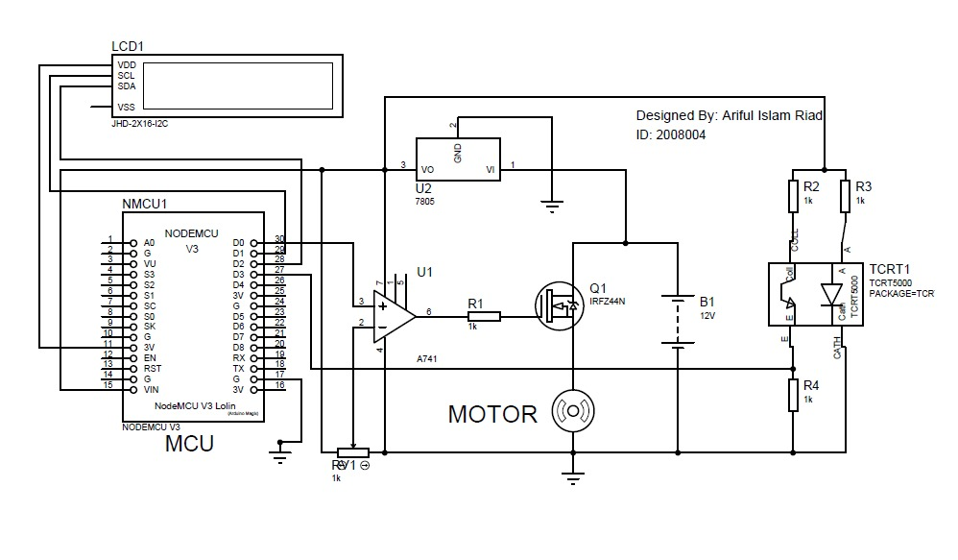
Programme
C++ Programme of implementation of the motor control system
#define BLYNK_TEMPLATE_ID "TMPL69FQrtyZB”
#define BLYNK_TEMPLATE_NAME "iot motor controller"
#define BLYNK_AUTH_TOKEN "h7256d_uH0mh4Hupc0DKJiT1gAM0CneH"

#include <Arduino.h>
#include "functions.h"

#define BLYNK_PRINT Serial
#include <ESP8266WiFi.h>
#include <BlynkSimpleEsp8266.h>
#include <SPI.h>
#include <Wire.h>
#include <Adafruit_GFX.h>
#include <Adafruit_SSD1306.h>

#define MOTORPWM D7
#define OPTO D6

#define SCREEN_WIDTH 128
#define SCREEN_HEIGHT 64

#define SCREEN_ADDRESS 0x3C
Adafruit_SSD1306 display(SCREEN_WIDTH, SCREEN_HEIGHT, &Wire, -1);

void displayMotorRPM();
int setmotorspeed = 0;
int motorspeed = 0;
float RPM= 0;

unsigned long millisBefore;

volatile int gaps;
char auth[] = "h7256d_uH0mh4Hupc0DKJiT1gAM0CneH"; // Enter your Blynk Auth token
char ssid[] = "AndroidAP"; // Enter your WIFI SSID
char pass[] = "88880000"; // Enter your WIFI Password

BlynkTimer timer;
void IRAM_ATTR count()
{
gaps++;
}
void setup()
{
Serial.begin(115200);
display.begin();
if (!display.begin(SSD1306_SWITCHCAPVCC, SCREEN_ADDRESS))
{

Serial.println(F("SSD1306 allocation failed"));
for (;;);
}

display.clearDisplay();
display.setTextSize(1);
display.setTextColor(SSD1306_WHITE);
display.setCursor(10, 15);
display.print("CONNECTING SERVER");
display.setCursor(10, 25);
display.print("SERVER READY");
display.setCursor(10, 35);
display.print("MOTOR READY");
display.display();
delay(2000);

display.clearDisplay();
display.setTextSize(1);
display.setTextColor(SSD1306_WHITE);
display.setCursor(10, 15);
display.print("WEB CONTROLLED");
display.setCursor(10, 25);
display.print("HAND MADE MOTOR");
display.setCursor(10, 40);
display.print("GROUP_1(1-6)");
display.display();
delay(2000);

display.clearDisplay();
display.setTextSize(1);
display.setTextColor(SSD1306_WHITE);
display.setCursor(5, 10);
display.print("INPUT RPM : ");
display.print(setmotorspeed);
display.setCursor(5, 20);

analogWrite(MOTORPWM, 1023);

attachInterrupt(digitalPinToInterrupt(D6), count, FALLING);
Blynk.begin(auth, ssid, pass, "blynk.cloud", 80);
timer.setInterval(500L, displayMotorRPM);
}
BLYNK_WRITE(V0)

BLYNK_WRITE(V0)
{
setmotorspeed = param.asInt();
Serial.println(setmotorspeed);
int x = map(setmotorspeed, 0, 6000, 0, 1023);
analogWrite(MOTORPWM, x);
display.clearDisplay();
display.setTextSize(4);
display.setTextColor(SSD1306_WHITE);
display.setCursor(5, 10);
display.print("INPUT RPM : ");
display.print(setmotorspeed);
display.setCursor(5, 20);
display.print("MOTOR RPM : ");
display.print(RPM);
display.display();
}
BLYNK_CONNECTED()
{
Blynk.syncVirtual(V0);
}

void loop()
{
if (millis() - millisBefore > 1000)
{
RPM= (gaps / 20.0)*60;
gaps = 0;
millisBefore = millis();
}

Blynk.run();
timer.run();
}

display.print("MOTOR RPM : ");
display.print(motorspeed);
display.display();

pinMode(MOTORPWM, OUTPUT);
pinMode(OPTO, INPUT);

analogWrite(MOTORPWM, 1023);

attachInterrupt(digitalPinToInterrupt(D6), count, FALLING);
Blynk.begin(auth, ssid, pass, "blynk.cloud", 80);
timer.setInterval(500L, displayMotorRPM);
}

BLYNK_WRITE(V0)
{
setmotorspeed = param.asInt();
Serial.println(setmotorspeed);
int x = map(setmotorspeed, 0, 6000, 0, 1023);
analogWrite(MOTORPWM, x);
display.clearDisplay();
display.setTextSize(4);
display.setTextColor(SSD1306_WHITE);
display.setCursor(5, 10);
display.print("INPUT RPM : ");
display.print(setmotorspeed);
display.setCursor(5, 20);
display.print("MOTOR RPM : ");
display.print(RPM);
display.display();
}
BLYNK_CONNECTED()
{
Blynk.syncVirtual(V0);
}

void loop()
{
if (millis() - millisBefore > 1000)
{
RPM= (gaps / 20.0)*60;
gaps = 0;
millisBefore = millis();
}

Blynk.run();
timer.run();
}

Github :

https://github.com/fahimcodebag/electronics/pull/1/commits/c7bde31c99a9e2a7c8a5e63b3c78d6eaf33700de


Contributions

Armature winding : Nurul Sajjad, Nishat Pervez Meghoboti, Homayra Mobesshira Hemu

Commutator and Brush : Fahad Bin Islam, Ariful Islam Riad, Fahim Faisal

Motor Assembly : Fahad Bin Islam, Ariful Islam Riad, Fahim Faisal , Homayra Mobesshira Hemu

Circuit Design : Fahim Faisal , Ariful Islam Riad , Nurul Sajjad

Circuit Implementation : Fahim Faisal, Ariful Islam Riad.

Coding : Fahim Faisal, Ariful Islam Riad.

